Online courses in Library Management: Library Juice Academy's Certificate in Library Leadership and Management as a case study

Course content highlights
List of the courses in the “Certificate in Library Leadership and Management”
- Effective Communication Strategies (February)
- Planning and Leading Effective Team Meetings (March)
- Strategic Planning: Setting Directions for the Future (April)
- Critical Strategies for Implementing and Managing Organizational Change (May)
- Growing, Developing, and Retaining Dynamic Staff (June)
- Telling Your Story: Successful Marketing Strategies for Librarians (July)
So far the first course, Effective Communication Strategies, has been my favorite! Probably because it is the one that directly applies the most to my current job responsibilities. I learned about active listening and active questioning which I found very useful, even for everyday life. One week was dedicated to holding difficult discussions with staff and gave handy tips!

Tips and tricks from the courses
“Listen to understand, don’t listen to answer”
“Let people explain their behavior and ask them to come up with a solution that suits them”
“When planning a meeting, always have an agenda and follow it”
“Your mission statement should be able to fit on a T-Shirt”
Suitability of the asynchronous online teaching
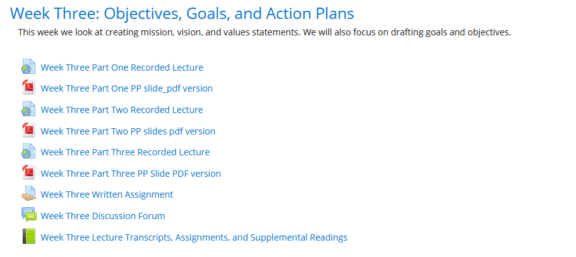
The asynchronous participation is extremely convenient! Lectures are available online and can be either listened to or read (a transcript is available) or both. Everybody participates at a time that is suitable to them and I have found this very practical!
As you can see beside there is also a reading assignment, written assignment and discussion forum to take part in every week.

Helpfulness of the documentation provided
The course does not give access to any templates, charts or step by step guidelines. It gives the links to the weekly assigned reading and to other recommended articles on the subject. The content of some lectures could be used to create guidelines and templates.

Articles I found enlightening
https://courses.eller.arizona.edu/mgmt/delaney/p_chapter1.pdf (About selective perceptions)
https://www.maxwell.syr.edu/uploadedFiles/parcc/cmc/Reflective%20Listening%20NK.pdf (On reflective listening)
http://hrweb.mit.edu/learning-development/learning-topics/meetings/articles/agendas (How and why to use a meeting agenda)
https://www.newyorker.com/magazine/2012/01/30/groupthink (Great article about the importance of colleague collaboration and “accidental hallway meetings”)

Applicability to real life situation
The Lectures use examples in Libraries. What mainly makes it applicable to everybody’s own situation are the assignments and discussion forum: we are asked to reflect on situations that happened to us in the past or are happening currently at our institution and imagine how we could address it. Some assignments also involve SWOT analysis, survey questioning, or planning. Always with our library in mind, so that the documents we create for our assignments can really be used.

Challenges
The biggest challenge is finding the time to dedicate to the course, readings and assignments during busy weeks!
They announce you’ll spend an average of 4 hours weekly for the course. I have dedicated about 6 hours per week.

Contacts
Thanks for reading!
I’d be very happy to answer any question you may have or give additional details

Clélie Riat
Instructional and Access Services Librarian
Franklin University Switzerland
criat@fus.edu

Some other providers of online training for librarians
In case you are interested in following some online professional development, I have created a list of some other suppliers. Please note that this is just a collection of practicalities gathered from each course provider’s website. I cannot vouch on the quality or provide details as I have only taken the one series with Library Juice Academy.
Name | Description from their website | Duration | Price
American Library Association (ALA) offers online learning through its various divisions:  - Association of College and Research Libraries (ACRL)  - Reference and User Services Association (RUSA)  - Association for Library Collections and Technical Services (ALCTS)  - Library Information Technology Association (LITA) | http://www.ala.org/acrl/conferences/elearning/courses  ACRL e-Learning courses are multi-week, online courses delivered through the Moodle platform. Course activities are primarily asynchronous and require approximately 3-5 hours a week to :  Read the online course materials  Post to online discussion boards  Complete online exercises and/or final assignment  http://www.ala.org/rusa/development/onlinece  All courses are hosted asynchronously in Moodle.  http://www.ala.org/alcts/confevents  http://www.ala.org/lita/learning/online  A Web Course meets for multiple sessions |  | 210$  (non-members)
Amigos Library Services | http://www.amigos.org/  Live Online System Requirements:  A microphone or headset with microphone is recommended, but not required. Students without a microphone contribute to conversations through text chat. | 1-2 hours | 35-200$  (non-members)
Art Teacher on the Net | http://librarianworkshops.com/  Unit 1 opens the first week, access at your convenience and interact with other participants and the instructor on the forum, read the lecture, and watch the videos. Unit 1 will remain open throughout the 4 weeks, Unit 2 opens the second week, etc. There will be an additional 2 weeks to catch up if you have to miss a week. | 4 weeks | 125$
Australian Library and Information Association | https://www.alia.org.au/training  - Contact with facilitators will be through online forums on Moodle (the online Learning Management System).  - Participants will connect with each other through forum discussions.  - There are no specific times you need to be available.  - The time investment required is approximately 4-5 hours per week, depending on the individual.  - The course can be completed in 4 weeks but as it is developed to be self-paced, it can be finished earlier or later depending on your learning styles and needs. If you wish to vary the usual time taken, please discuss this with your teacher at the outset.  - No specific hardware and software, other than a computer with internet access, is required for this course, although being able to try out apps on your own mobile device would be useful. | 4 weeks | 455 AUD$  (non-members)
Library Journal Professional Development | https://learn.libraryjournal.com/courses/  - Instructor-led online courses feature personalized interaction over three weeks  - Real-time guest speakers and conversation via live webcast (with recordings available afterward)  - Homework assignments to help you make progress on your goals  - Individualized attention from course facilitators who work with you in a coaching environment to help sort out challenges  - Ongoing group conversation via discussion forums  - Articles, videos and other resources  - Access all course content for 6 months after the course ends | 3 weeks  (3x 2 hours Live sessions) | 225-281.25$
Library Juice Academy | https://www.libraryjuiceacademy.com/courses.php  Your login for the course will remain active indefinitely, so you can continue to access course materials, feedback, and discussions. | 4 weeks | 175 $

